III Year B.Tech Application Development III (AD-II) Project Review

EAT-SMART


Batch Details

S.AKSHAYA :23N31A67L5 T.PRANAVI :23N31A67N4 S.MOHAN SAI TEJ :23N31A67M1

Under the guidance of
Mrs S.Rajitha , Assistant Professor
School of Emerging Technologies (CSE-Data Science)
Malla Reddy College of Engineering & Technology
(UGC Autonomous Institution – Govt. of India)

Abstract

EAT-SMART is an advanced mobile application designed to support healthy eating habits through intelligent food tracking and weekly dietary analysis. Users log meals from a predefined dataset, and the system evaluates eating patterns to generate structured weekly reports highlighting progress and goal achievement. Based on this analysis, EAT-SMART provides personalized diet tips and motivational encouragement to guide users throughout their dietary journey. Visual charts and progress indicators enable easy understanding of trends and improvements. The application stores data locally using SQLite for offline accessibility and is developed using Flutter and Dart in Visual Studio Code, demonstrating efficient data handling, analytical processing, and user-centric mobile application design.
To develop this project we use algorithms such as :
RULE-BASED CLASSIFICATION, PATTERN ANALYSIS, RECOMMENDATION-ENGINE,
PROGRESS SCORING not only that also we use patterns like TIME-SERIES PATTERN, FREQUENCY PATTERN, GOAL MATCHING PATTERN, BEHAVIORAL INNOVATION.

Introduction

- Modern lifestyles often lead to unhealthy eating habits and irregular meal patterns.

- Maintaining a balanced diet is challenging without proper tracking and guidance.

- EAT-SMART helps users monitor daily food intake and analyze weekly dietary patterns.

- Provides personalized diet tips and motivational encouragement to stay consistent.

- Visual progress reports and charts allow users to track improvement over time.

- Developed using Flutter and Dart with SQLite for offline data storage.

- Demonstrates efficient data handling, analytical processing, and user-centric design.

Existing System
Most current diet apps only track daily food intake and calories. They lack weekly analysis, personalized suggestions, and motivational support, and often require constant internet access. Limited visual feedback makes them less effective in helping users maintain healthy eating habits.
⚠️ Limitations of the Existing System

Only tracks daily food intake, no weekly analysis.
- Lack of personalized diet suggestions or motivational support.
- Poor user engagement; does not encourage consistency.
- Often internet-dependent, restricting offline usage.
- Visual reports and progress tracking can be confusing or inadequate.
- Limited ability to analyze eating patterns over time.

Proposed System

EAT-SMART provides weekly analysis, personalized diet tips, and motivational support to help users maintain healthy eating habits. It generates visual progress reports, tracks meals, and offers guidance for consistency, all while being offline-accessible and user-friendly.
⭐ Key Features of EAT-SMART:
- Tracks daily food intake and weekly patterns.
- Provides personalized diet suggestions based on user goals.
- Generates visual progress reports and charts.
- Sends motivational messages and encouragement.
- Works offline using local SQLite storage.
- Designed to be scalable for AI or cloud integration in future.
- It also provides reviews/feedbacks from the previous users.

System Architecture


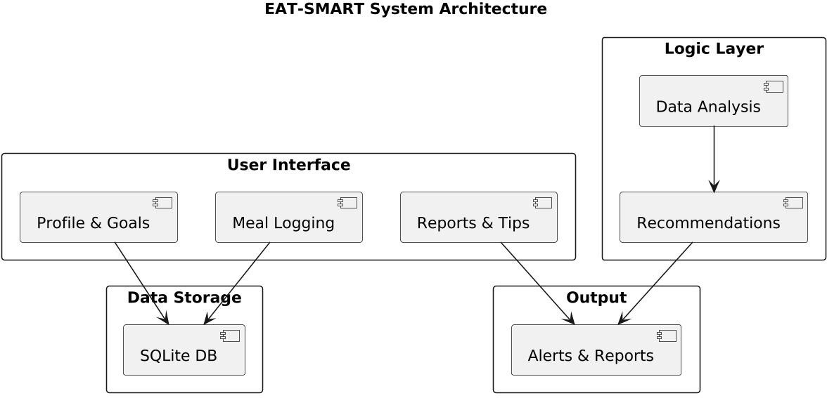
System Architecture

School of Emerging Technologies: CSE (DS), CSE(IoT) & CSE(CyS) | MRCET (A) Campus

Technical Requirements Specification (TRS)

Software Requirements Specification(SRS)

- Framework & Language: Flutter & Dart
- IDE: Visual Studio Code
- Database: SQLite (local storage)
- UI: Login, Meal Logging, Reports & Tips (Flutter widgets)
- Logic: Data Analysis & Personalized Recommendations
- Features: Weekly charts, motivational alerts, offline access
- Libraries: sqflite, flowchart, provider/bloc, flutter _local_ notifications

Hardware Requirements Specification(HRS)
PC/Laptop: Intel i3/i5, 8 GB RAM, 256 GB storage Mobile Device: Android 7+, 2 GB RAM, 16 GB storage OS: Windows/macOS/Linux
Connectivity: USB or wireless for testing

Application Modules
- User Authentication Module
- User Profile Management
- BMI Calculation and Classification Module
- Meal Plan Generator
- Daily Diet Tracker
- Pattern Analysis Module
- Recommendation Engine
- Report Generation Module
- Local Data Storage Module
- User Interface Module

System Models
(UML Diagrams)

Dataflow Diagram

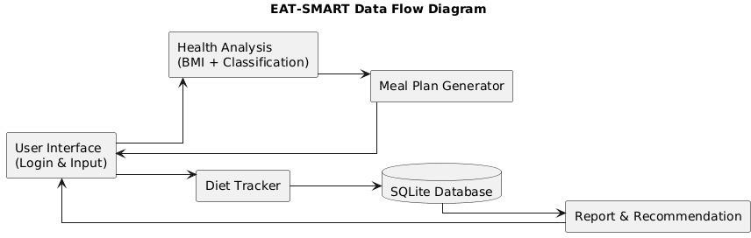


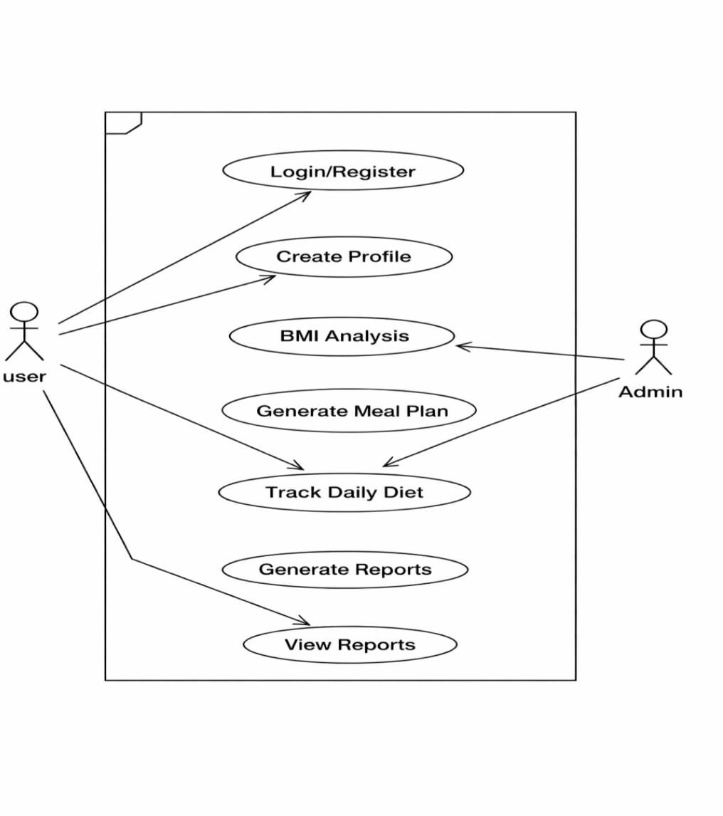
Use Case Diagram

School of Emerging Technologies: CSE (DS), CSE(IoT) & CSE(CyS) | MRCET (A) Campus



School of Emerging Technologies: CSE (DS), CSE(IoT) & CSE(CyS) | MRCET (A) Campus
Sequential Diagram

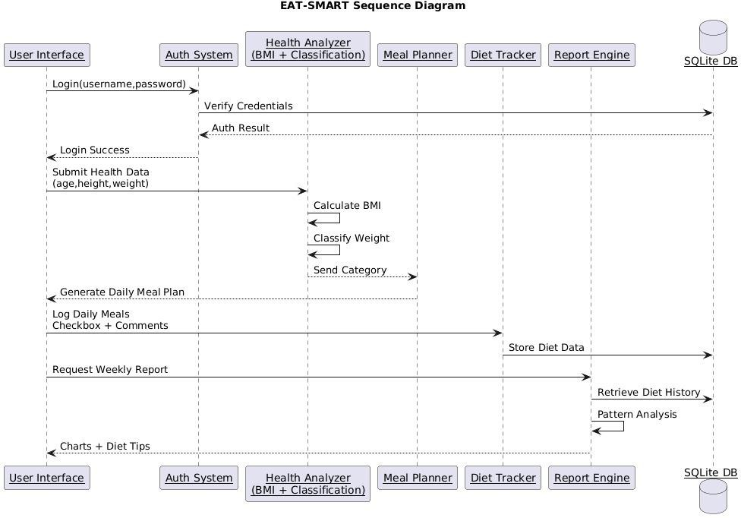


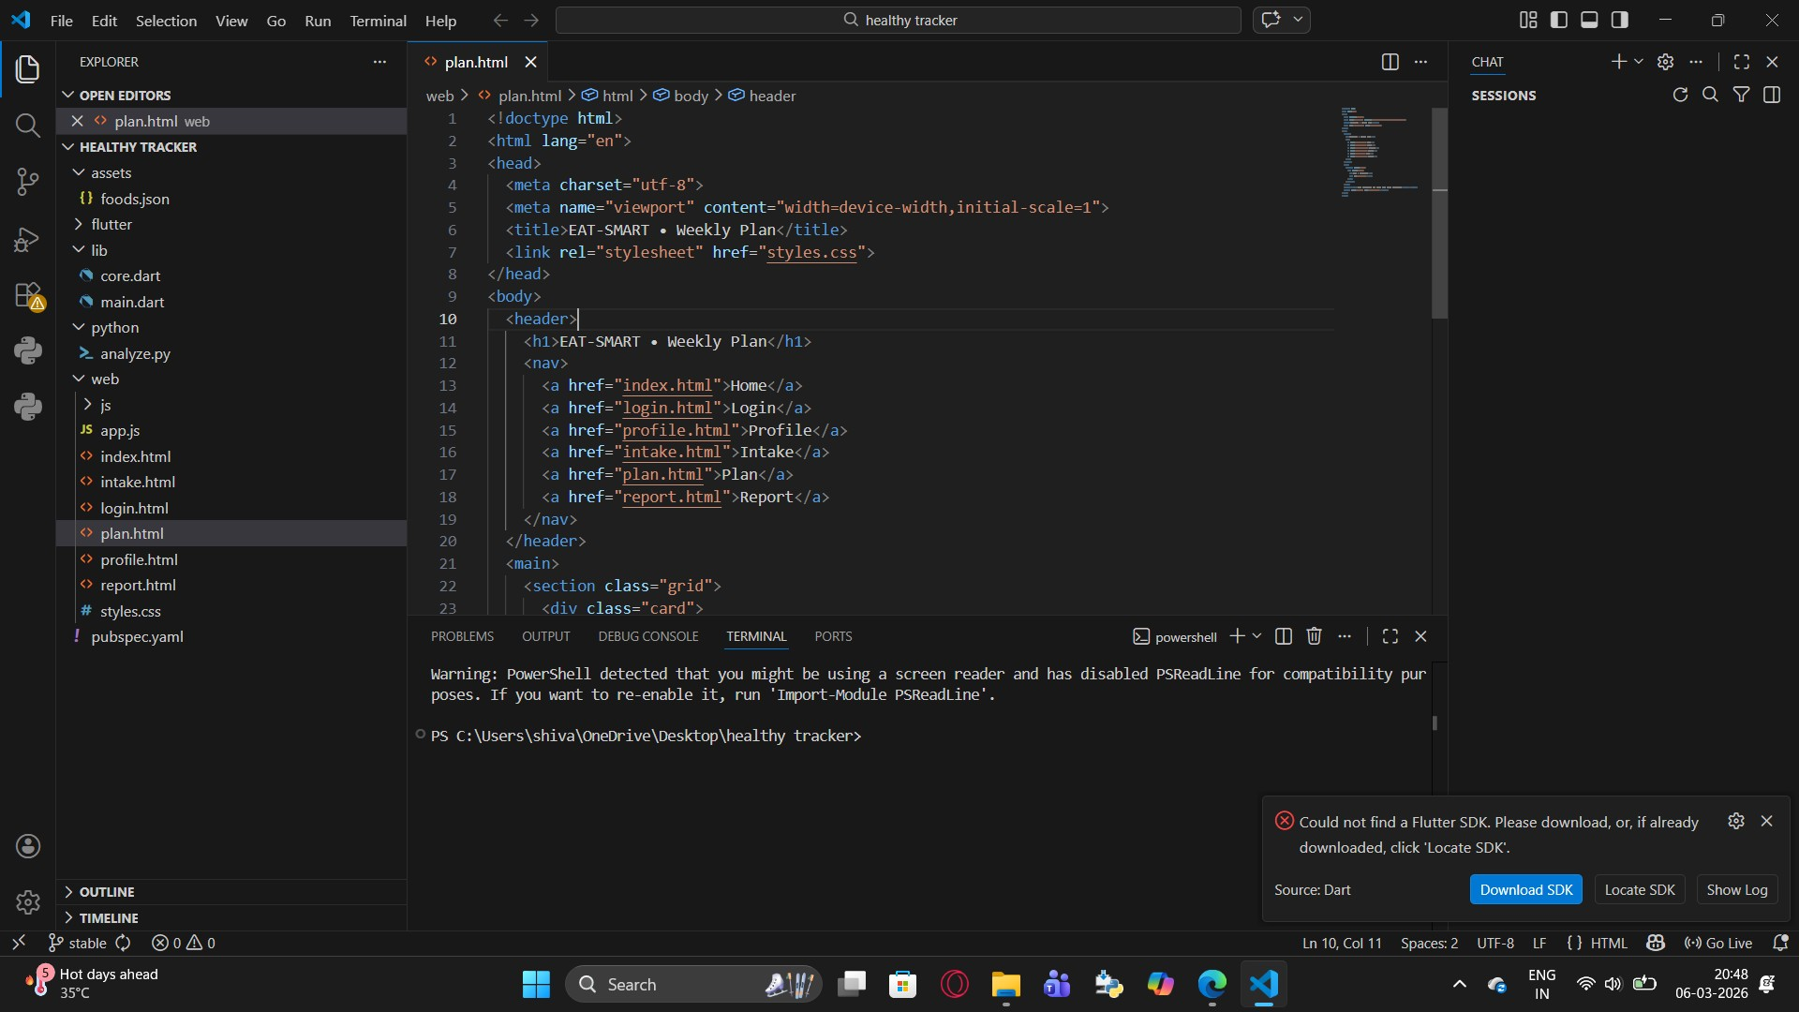
Implementation

School of Emerging Technologies: CSE (DS), CSE(IoT) & CSE(CyS) | MRCET (A) Campus


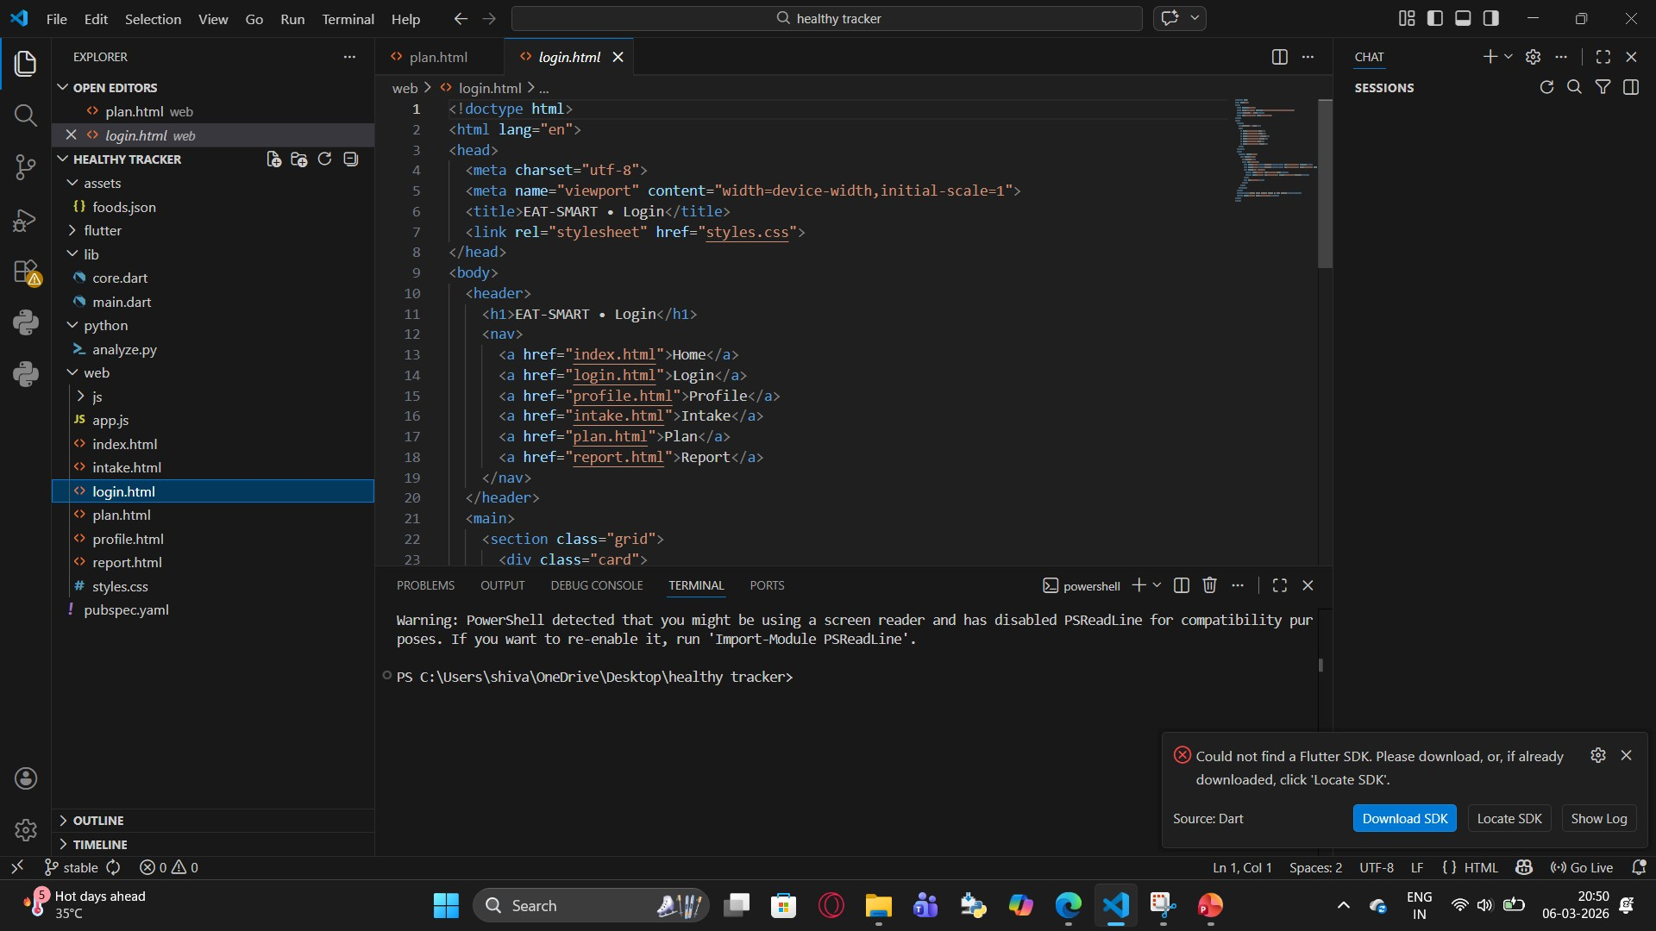
Implementation

School of Emerging Technologies: CSE (DS), CSE(IoT) & CSE(CyS) | MRCET (A) Campus


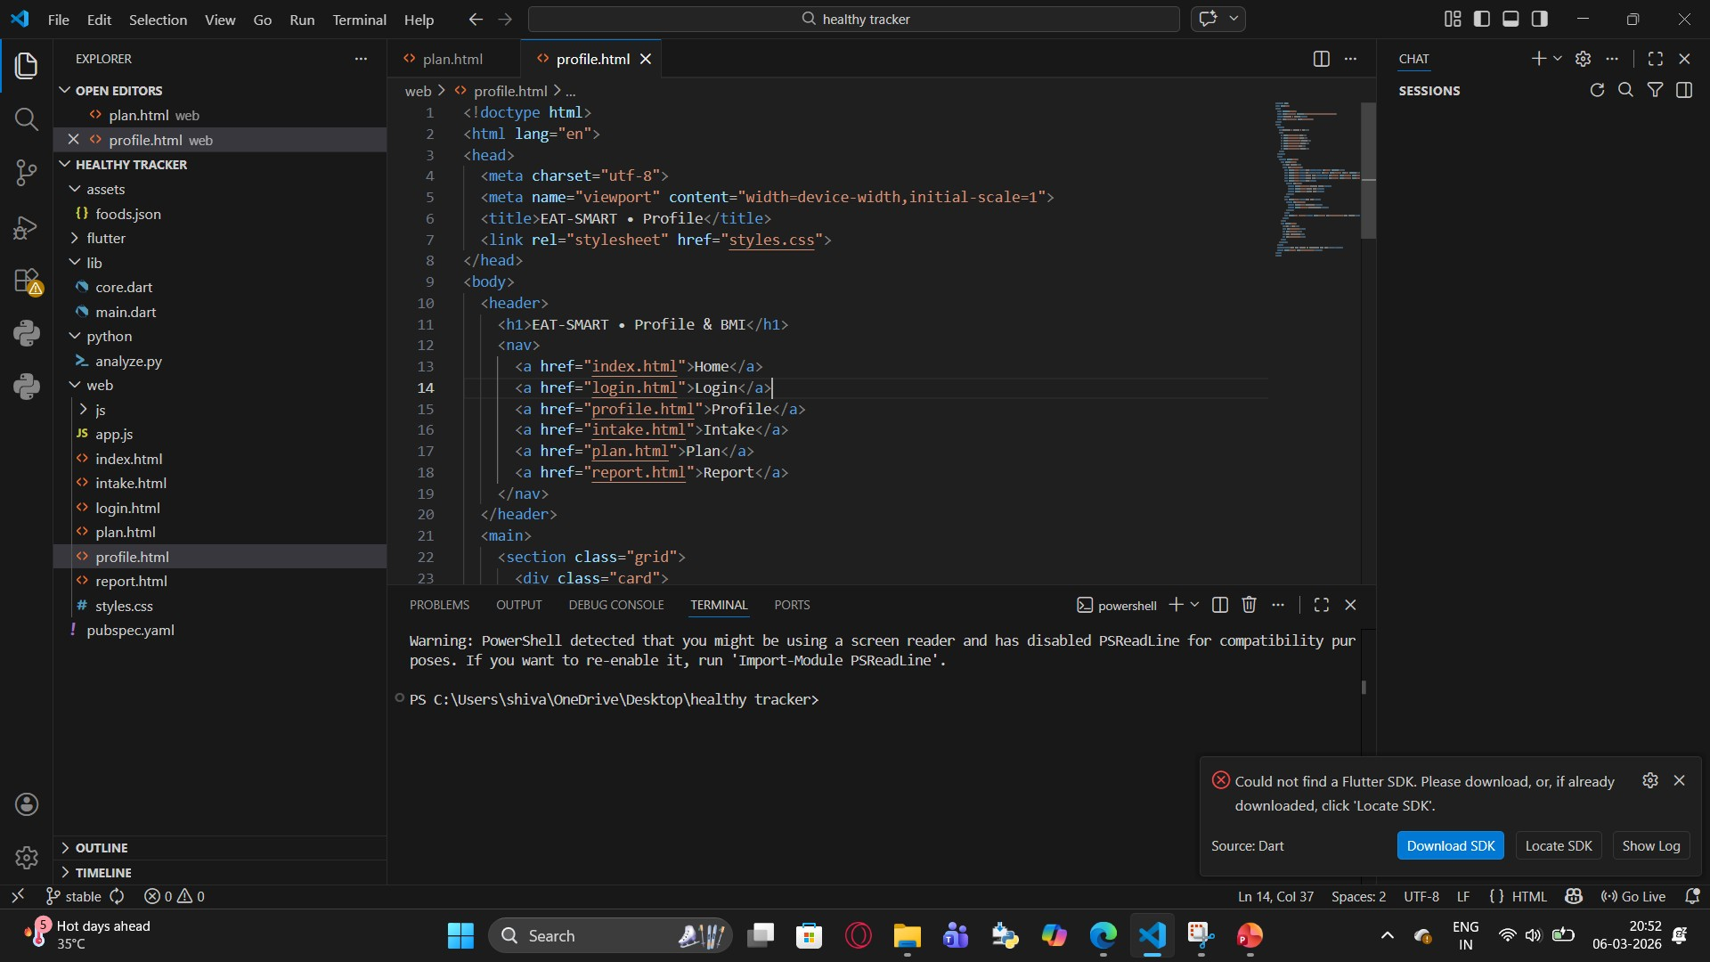
Implementation

School of Emerging Technologies: CSE (DS), CSE(IoT) & CSE(CyS) | MRCET (A) Campus



School of Emerging Technologies: CSE (DS), CSE(IoT) & CSE(CyS) | MRCET (A) Campus

Output Screens


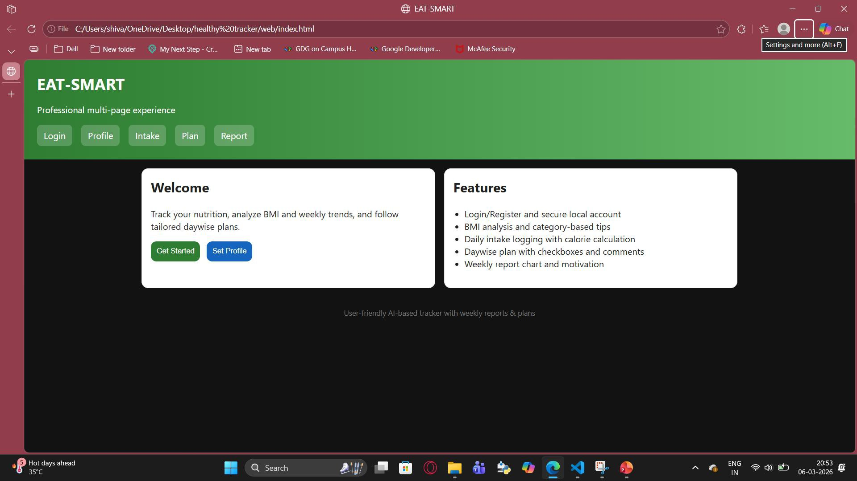

School of Emerging Technologies: CSE (DS), CSE(IoT) & CSE(CyS) | MRCET (A) Campus

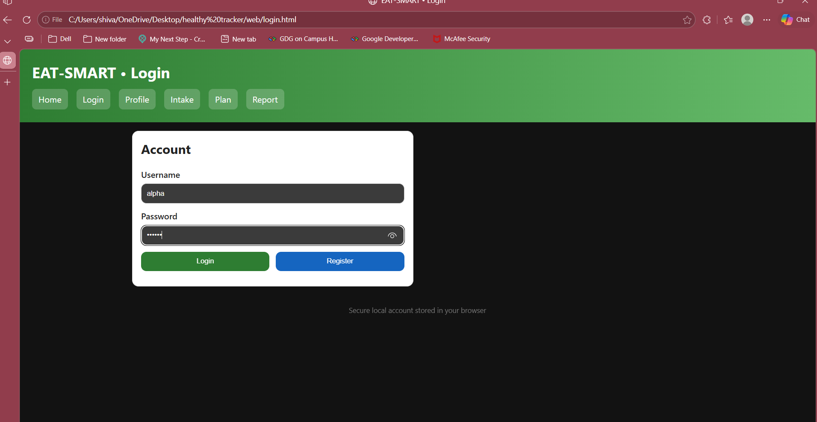

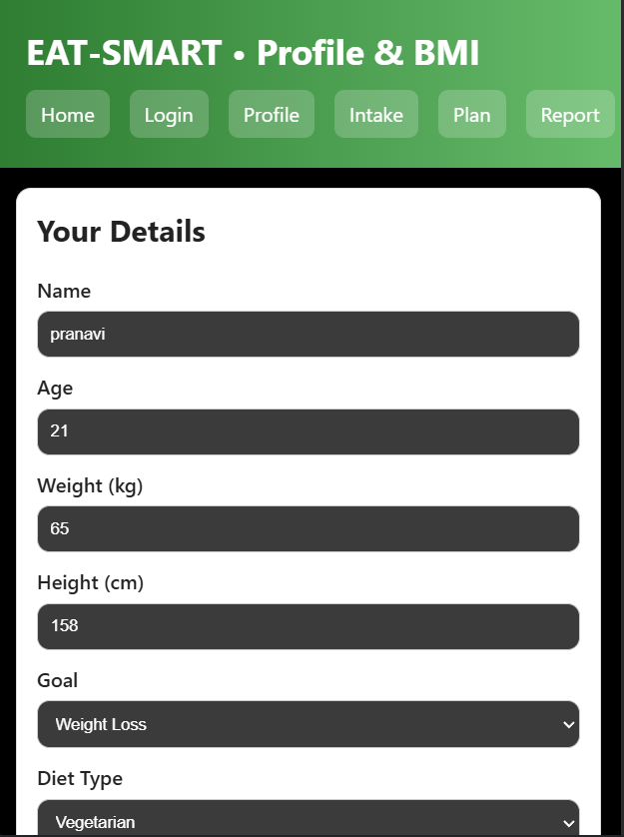
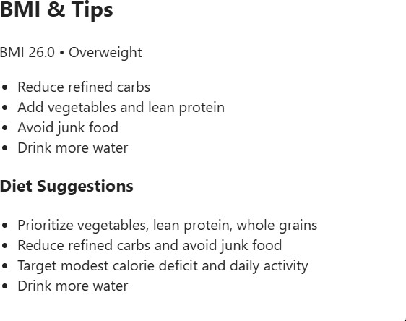
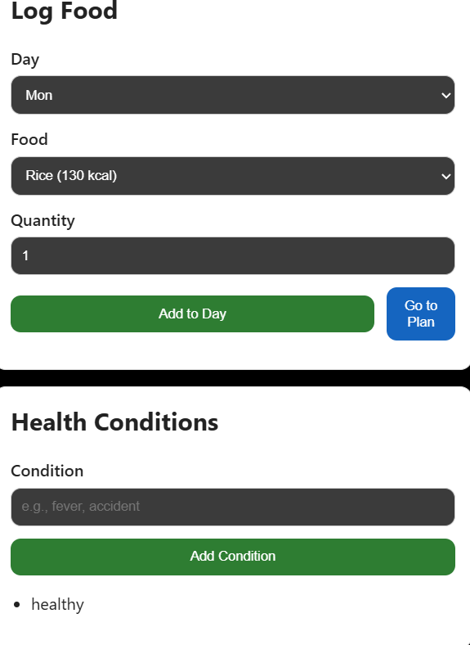

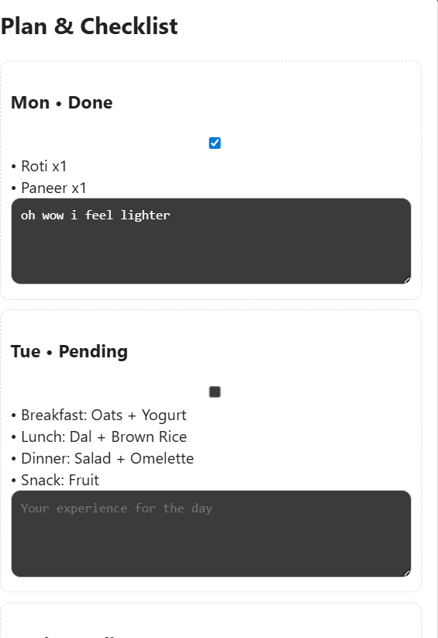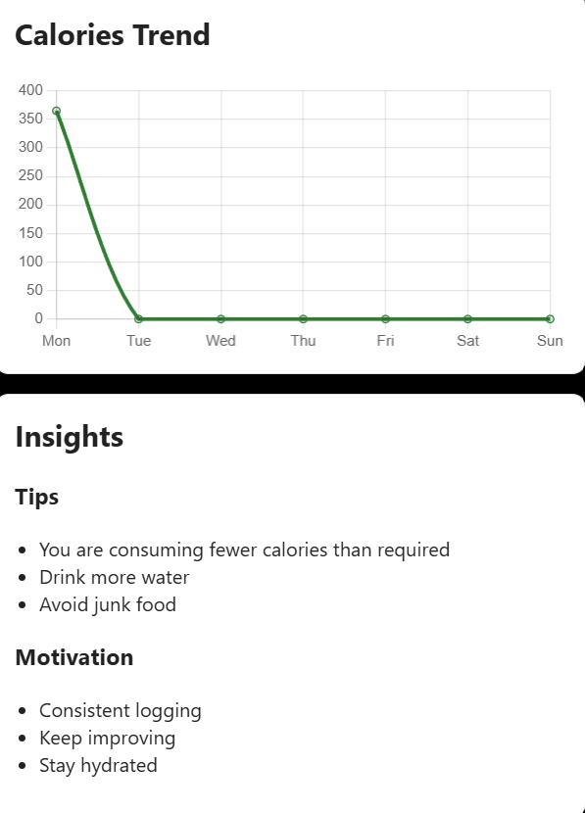

Conclusion & Future Scope

Conclusion

EAT-SMART is an intelligent mobile application that helps users maintain healthy eating habits through effective food tracking and analysis. It provides personalized suggestions, visual progress reports, and motivational support to guide users toward their dietary goals.
- Tracks daily meals and analyzes weekly patterns
- Provides personalized diet recommendations
- Displays progress through visual charts and reports
- Encourages users with motivational feedback
- Works offline using SQLite for reliability
- Scalable for future AI and cloud integration

Future Scope
EAT-SMART has strong potential for future enhancements by integrating advanced technologies and expanding its features. With improvements like AI-based recommendations and cloud connectivity, the application can provide more accurate insights and a better user experience.
- Integrate AI/ML for smarter and personalized diet suggestions
- Enable cloud storage for data backup and multi-device access
- Add wearable device integration for real-time health tracking
- Implement barcode scanning and image-based food recognition
- Expand the food database with real-time updates
- Introduce social features like challenges and community support
- Provide multilingual support for wider accessibility
- Offer advanced health analytics and insights

Thank You
1.S.AKSHAYA : 23N31A67L5
2.T.PRANAVI : 23N31A67N4
3.S.MOHAN SAI TEJ : 23N31A67M1

